**Project Planning Phase**

**PROJECT PROGRESS TRACKING**

# Tracking progress on your project board

You can see the overall progress of your project board in a progress bar. If progress tracking is enabled, a progress bar appears above the project board, on the project listing page, in the issue sidebar, and in references to the project on other project boards.

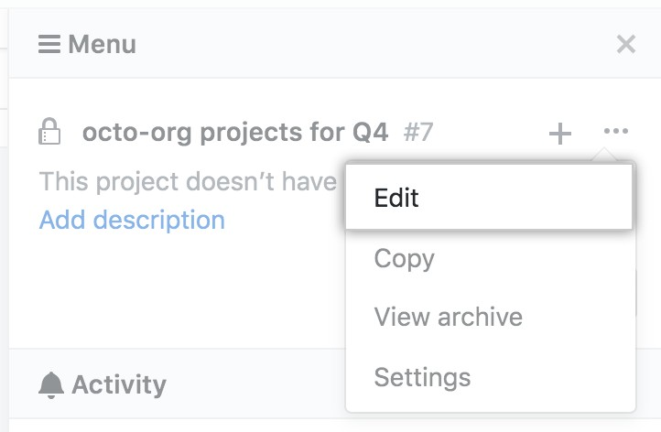

1. Navigate to the project board where you want to enable or disable project progress tracking.
2. On the top-right side of the project board.

# About projects

Projects (classic) on GITHUB help you organize and prioritize your work. You can create classic projects for specific feature work, comprehensive roadmaps, or even release checklists. With projects (classic), you have the flexibility to create customized workflows that suit your needs.

# Creating a project

Classic projects can be used to create customized workflows to suit your needs, like tracking and prioritizing specific feature work, comprehensive roadmaps, or even release checklists.

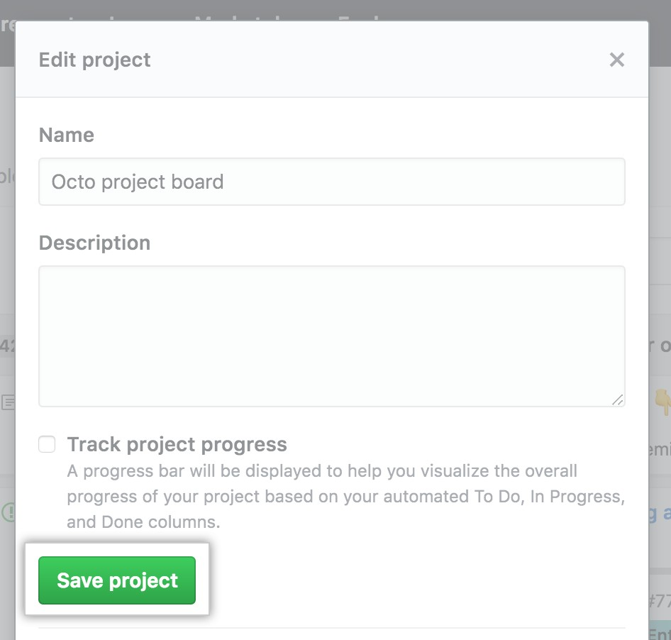

# Editing a project

You can edit the title and description of an existing classic project.

# Linking a repository to a project

You can link a repository to your organization's or personal account's classic project.

1. Navigate to the classic project where you want to link a repository.
2. On the top-right side of the classic project, click **Menu**.
3. Click then click **Settings**.
4. Click , then click **Settings**.

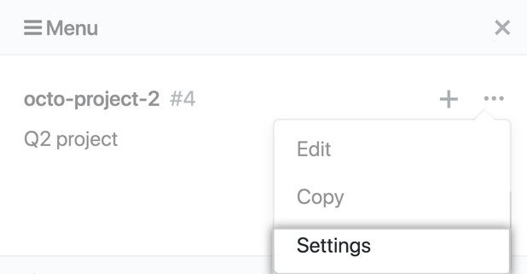

1. In the left sidebar, click **Linked repositories**.

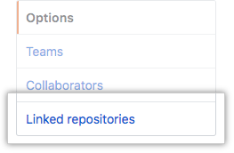

1. Click **Link a repository**.

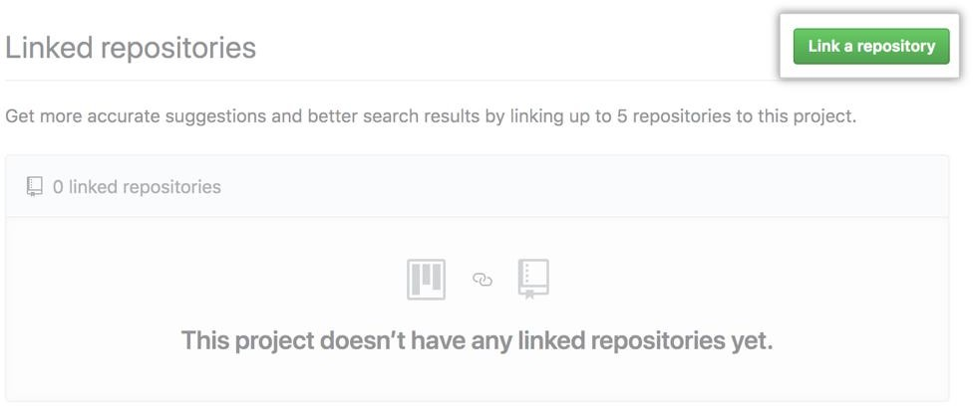

1. 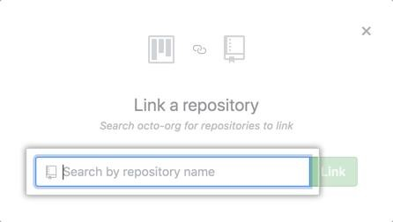Search for the repository you'd like to link.
2. Click **Link**. To unlink, click **Unlink**.